**[GENERAL ELECTION DATABASE OF 2024]**

**Database Design Document**

**V 2.0**

**By**

|  |  |  |
| --- | --- | --- |
| 1 | *USAIRA SHAHBAZ* | *NUM-BSCS-2022-27* |
| 2 | *DAWOOD HABIB KHAN* | *NUM-BSCS-2022-31* |
| 3 | *LARAIB SULTANA* | *NUM-BSCS-2022-06* |



**Department of Computer Sciences**

**Namal University**

**Mianwali, Pakistan**

**Submission Date: 10th June, 2024**

**REVISION HISTORY**

|  |  |  |  |
| --- | --- | --- | --- |
| **Date** | **Version** | **Description** | **Approved by** |
| 10June,2024 | V.1.0 | Updated ER diagram, Rewrites problem statement | Mam. Asiya Batool |

**TABLE OF CONTENTS**

CHAPTER 1: PROJECT OVERVIEW 5

1.1. INTRODUCTION: 5

1.2. PROBLEM STATEMENT: 5

1.3. PROJECT OBJECTIVES: 5

1.4. DOCUMENT OBJECTIVES: 5

CHAPTER 2: DETAILED DATABASE DESIGN 6

2.1. ENTITY: 6

2.2. DATA DICTIONARY: 6

2.3. RELATIONSHIPS: 7

2.4. ENTITY RELATIONSHIP DIAGRAM: 7

Chapter 3 : Logical DATABASE DESIGN 9

3.1. RELATIONAL SCHEMA: 9

3.2. FUNCTIONAL DEPENDENCIES: 9

3.2.1. TABLE: PARTIES 9

3.2.2. TABLE: WNNINGCANDIDATES 10

3.2.3. TABLE: PARTYPOSITION 10

3.2.4. TABLE: PROVINCEWISEVOTERS 10

3.2.5. TABLE: SEATSDISTRIBUTION 11

3.3. NORMALIZATION: 11

3.3.1. 1NF: 11

3.3.1.1. TABLE: PARTIES 11

3.3.1.2. TABLE: WINNINGCANDIDATES 11

3.3.1.3. TABLE: PARTYPOSITIONS 11

3.3.1.4. TABLE: PROVINCEWISEVOTERS 11

3.3.1.5. TABLE: SEATSDISTRIBUTIONS 11

3.3.2. 2NF: 11

3.3.2.1. TABLE: WINNINGCANDIDATES 11

3.3.2.2. TABLE: PARTYPOSITIONS 12

3.3.2.3. TABLE: SEATSDISTRIBUTIONS 12

3.3.2.4. TABLE: PROVINCEWISEVOTERS 12

3.3.3. 3NF: 12

3.3.3.1. TABLE: PARTIES 12

3.3.3.2. TABLE: WINNINGCANDIDATES 13

3.3.3.3. TABLE: PARTYPOSITIONS 13

3.3.3.4. TABLE: SEATSDISTRIBUTIONS 13

3.3.3.5. TABLE: PROVINCEWISEVOTERS 13

4. : Physical DATABASE DESIGN 15

4.1. STRUCTURE OF THE TABLES: 15

4.1.1. TABLE: PARTIES 15

4.1.2. TABLE: CANDIDATES 15

4.1.3. TABLE: WINNINGCANDIDATES 15

4.1.4. TABLE: PARTYSYMBOLS 16

4.1.5. TABLE: PROVINCEWISEVOTERS 16

4.1.6. TABLE: PARTYPOSITIONS 17

4.1.7. TABLE: SEATSDISTRIBUTION 17

4.2. DATA SAMPLES INSIDE TABLES: 18

4.2.1. TABLE: PARTIES 18

4.2.2. TABLE: CANDIDATES 18

4.2.3. TABLE: WINNINGCANDIDATES 19

4.2.4. TABLE: PARTYSYMBOLS 20

4.2.5. TABLE: PROVINCEWISEVOTERS 20

4.2.6. TABLE: PARTYPOSITIONS 21

4.2.7. TABLE: SEATSDISTRIBUTION 23

4.3. QUERIES RESULTS: 23

REFERENCES 31

# PROJECT OVERVIEW

## INTRODUCTION:

The primary purpose of this project is to provide detailed insights into the electoral process, including the distribution of seats among political parties, the winners in each electoral district. By organizing the electoral information into a structured database format, users can easily track the performance of political parties, identify winning candidates in each electoral district (NA).

## PROBLEM STATEMENT:

Historically, managing and analyzing electoral data in Pakistan has been a complex and time-consuming procedure. There is a lack of centralized structure. This fragmentation of information makes it difficult for stakeholders such `as political analysts, researchers, and the public to access and understand election results in an efficient manner. This project aims to deal with these challenges by creating a strong, organized database that combines and organizes electoral data, improving accessibility, transparency, and analytical capabilities for all users.

## PROJECT OBJECTIVES:

* Showcase the winners of each National Assembly (NA) constituency across every province.
* Present the distribution of seats in the Federal, Punjab, Sindh, Khyber Pakhtunkhwa (KPK), and Baluchistan assemblies.
* Provide district-wise voter statistics.
* Include polling station status to ensure transparency.
* Enlist and present the total number of participating political parties to offer a complete picture of the electoral landscape and party representation in the General Election of 2024.

## DOCUMENT OBJECTIVES:

* Documentation covers all aspects of the database project, including its purpose, challenges, solutions, objectives, and desired outcomes.
* Define the scope of the project, outlining the specific goals and deliverables to be achieved.
* Clearly articulate the objectives of the database project, including showcasing winners, presenting seat distribution, providing voter statistics, and ensuring transparency in polling station status.
* Provide insightful analysis and explanation of the challenges faced, solutions proposed, and the anticipated impact of implementing the database solution.

# DETAILED DATABASE DESIGN



## ENTITY:

|  |  |  |
| --- | --- | --- |
| **Sr. No** | **Entity Name** | **Description** |
| 1 | Parties | Information of all existing political parties and participating parties. |
| 2 | provincewisevoters | Province Wise Statistics of Voters. |
| 3 | Seat_distributions | National Assembly Seats distributions per province (Including Federal). |
| 4 | Winningcandidates | Information about winning candidates of National Assembly (Including polled, rejected and gained votes). |
| 5 | Party_position | Winning male and female seats of every participating party. |

## DATA DICTIONARY:

* + 1. **parties:**

|  |  |  |  |  |
| --- | --- | --- | --- | --- |
| **Sr. No** | **Name** | **Data Type** | **Constraint** | **Description** |
| 01 | PartyId | INT | Primary Key | Unique id of each party |
| 02 | PartyName | CHAR(50) | Not Null | Name of Party |
| 03 | PartyLeader | CHAR(25) | Not Null | Name of Party Leader |
| 04 | Isparticipating | BOOL | Not Null | Is single party participate in elections or not |
| 05 | Symbolcode | INT | Primary Key | Symbol code of every party |
| 06 | Partysymbol | CHAR(50) | Unique, Not Null | Every party symbol |

* + 1. **seatsdistribution:**

|  |  |  |  |  |
| --- | --- | --- | --- | --- |
| **Sr. No** | **Name** | **Data Type** | **Constraint** | **Description** |
| 01 | ProvinceName | CHAR(25) | Primary Key | Name of Province (Including Federal). |
| 02 | ProvinceSeats | INT | Not Null | Every party province seats. |

* + 1. **provincewisevoters:**

|  |  |  |  |  |
| --- | --- | --- | --- | --- |
| **Sr. No** | **Name** | **Data Type** | **Constraint** | **Description** |
| 01 | Provience_name | CHAR(25) | Primary Key | Name of provience |
| 02 | Male | INT | Not Null | Males voter statistic |
| 03 | Female | INT | Not Null | Female voter statistic |

* + 1. **winningcandidates:**

|  |  |  |  |  |
| --- | --- | --- | --- | --- |
| **Sr. No** | **Name** | **Data Type** | **Constraint** | **Description** |
| 01 | Seat_name | CHAR(50) | Unique | Name of nationalassembly seat |
| 02 | Candidate_name | CHAR(25) | NOT NULL | Name of party candidate |
| 03 | Candidate_id | INT | PRIMARY KEY | Unique id of each candidate |
| 04 | Party_id | INT | PRIMARY KEY | Unique id of each party |
| 06 | Polled_votes | INT | Not null | Total votes which are polled |
| 07 | Rejected_votes | INT | Not null | Votes rejected by polling officer |
| 08 | Gained_votes | INT | Not null | Votes gained by winning candidate |

* + 1. **partypositions:**

|  |  |  |  |  |
| --- | --- | --- | --- | --- |
| **Sr. No** | **Name** | **Data Type** | **Constraint** | **Description** |
| 01 | Territory_identity | CHAR(25) | Primary key | Name of Provinces |
| 02 | Party_id | INT | Primary key | Unique id of each party |
| 03 | Male | Integer | Not null | Winning male seats of every participating party. |
| 04 | Female | String | Not null | Winning female seats of every participating party. |

## RELATIONSHIPS:

|  |  |  |  |
| --- | --- | --- | --- |
| **Sr. No** | **Participating Entities** | **Relation** | **Business Rule** |
| 01 | Parties, winningCandidates | Has Winning Candidates | A Party may have multiple winning candidates, but each winning candidate is associated with exactly one Party. |
| 02 | Parties, partypositions | Has Position | Each party can have multiple positions in different territories (male, female), and each position is associated with one party. |

## ENTITY RELATIONSHIP DIAGRAM:

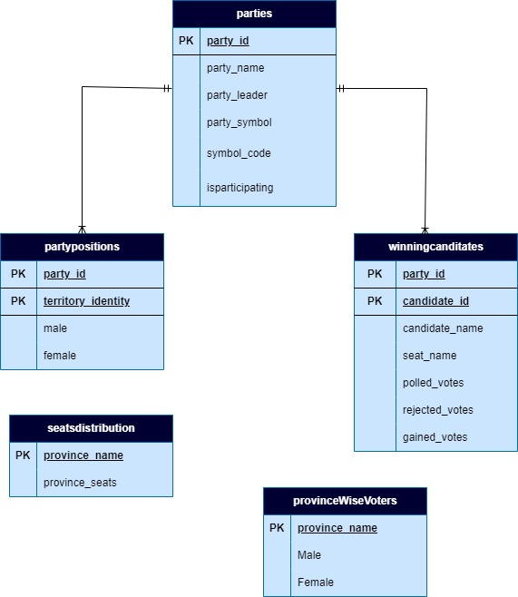

# : Logical DATABASE DESIGN

* 1. **RELATIONAL SCHEMA:**

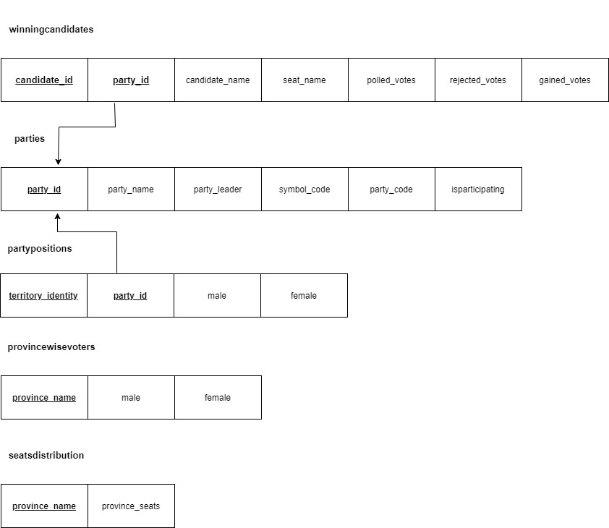

* 1. **FUNCTIONAL DEPENDENCIES:**
     1. **TABLE: PARTIES**

**FULLY DEPENDENCY**

Party_id 🡪 party_name, party_leader, party_symbol, symbol_code, isparticipating

Example: 3 🡪 PML, Muhammad Shehbaz Sharif, Tiger, 27, 1

**TRANSITIVE DEPENDENCY**

symbol_code 🡪 party_symbol

Example: 27 🡪 Tiger

* + 1. **TABLE: WNNINGCANDIDATES**

**FULLY DEPENDENCY**

Candidate_id,Party_id 🡪 candidate_name, seat_name, polled_votes, rejected_votes, gained_votes

Example: 1, 3 🡪 Anwar-ul-Haq, NA-75, 324255, 99625, 9881

**PARTIAL DEPENDENCY**

Candidate_id 🡪 candidate_name

Example: 1 🡪 Anwar-ul-Haq

* + 1. **TABLE: PARTYPOSITION**

**FULLY DEPENDENCY**

Territory_identity,Party_id 🡪 male, female

Example: 3, KPK 🡪 2,0

* + 1. **TABLE: PROVINCEWISEVOTERS**

**FULLY DEPENDENCY**

province_name 🡪 male, female

Example: Punjab🡪 39122082, 34085814

* + 1. **TABLE: SEATSDISTRIBUTION**

**FULLY DEPENDENCY**

province_name **🡪** provinceseats

*Example:* Sindh 🡪 61

* 1. **NORMALIZATION:**
     1. **1NF:**
        1. **TABLE: PARTIES**

Already in 1NF. No Multivalued attribute exists.

* + - 1. **TABLE: WINNINGCANDIDATES**

Already in 1NF. No Multivalued attribute exists.

* + - 1. **TABLE: PARTYPOSITIONS**

Already in 1NF. No Multivalued attribute exists.

* + - 1. **TABLE: PROVINCEWISEVOTERS**

Already in 1NF. No Multivalued attribute exists.

* + - 1. **TABLE: SEATSDISTRIBUTIONS**

Already in 1NF. No Multivalued attribute exists.

* + 1. **2NF:**
       1. **TABLE: WINNINGCANDIDATES**

Partial dependency exists

Candidate_id

gained_votes

rejected_votes

Polled_votes

Seat_name

Candidate_id

Party_id

(3NF)

Candidate_name

**3.3.2.2. TABLE: PARTIES**

* + - 1. **TABLE: PARTYPOSITIONS**

No Partial dependency exists. Male and female attributes fully depended on party_id and territory_identity.

* + - 1. **TABLE: SEATSDISTRIBUTIONS**

No partial dependency exists.

* + - 1. **TABLE: PROVINCEWISEVOTERS**

No partial dependency exists.

* + - 1. **TABLE: PARTIES**
    1. **3NF:**
       1. **TABLE: PARTIES**

symbol_code

isparticipating

Party_leader

Party_name

Party_id

(3NF)

symbol_code

Party_symbol

(3NF)

* + - 1. **TABLE: WINNINGCANDIDATES**

Already in 3NF.

* + - 1. **TABLE: PARTYPOSITIONS**

Already in 3NF.

* + - 1. **TABLE: SEATSDISTRIBUTIONS**

Already in 3NF Form.

* + - 1. **TABLE: PROVINCEWISEVOTERS**

Already in 3NF Form.

# : Physical DATABASE DESIGN

* 1. **STRUCTURE OF THE TABLES:**
     1. **TABLE: PARTIES**

**Query:**

DESCRIBE parties;

**Output:**

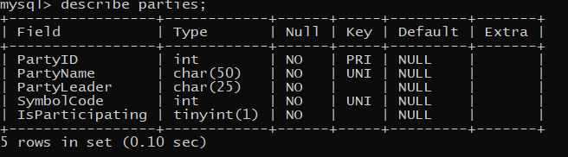

* + 1. **TABLE: CANDIDATES**

**Query:**

DESCRIBE candidates;

**Output:**

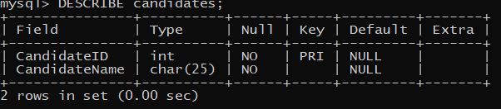

* + 1. **TABLE: WINNINGCANDIDATES**

**Query:**

DESCRIBE winningcandidates;

**Output:**

* + 1. **TABLE: PARTYSYMBOLS**

**Query:**

DESCRIBE PartySymbols;

**Output:**

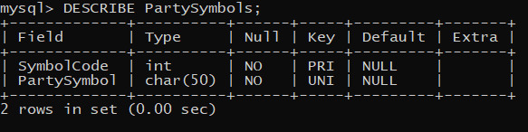

* + 1. **TABLE: PROVINCEWISEVOTERS**

**Query:**

DESCRIBE ProvinceWiseVoters;

**Output:**

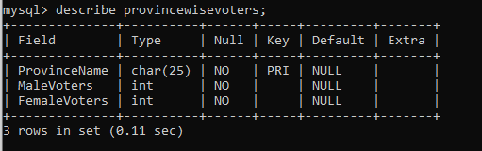

* + 1. **TABLE: PARTYPOSITIONS**

**Query:**

DESCRIBE PartyPositions;

**Output:**

* + 1. **TABLE: SEATSDISTRIBUTION**

**Query:**

DESCRIBE SeatsDistribution;

**Output:**

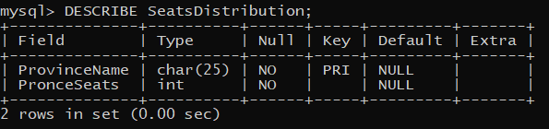

* 1. **DATA SAMPLES INSIDE TABLES:**
     1. **TABLE: PARTIES**

**Query:**

SELECT * from Parties;

**Output:**

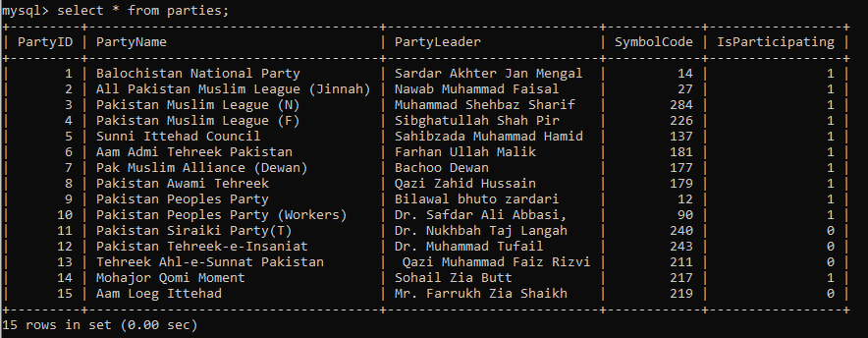

* + 1. **TABLE: CANDIDATES**

**Query:**

SELECT * from Candidates;

**Output:**

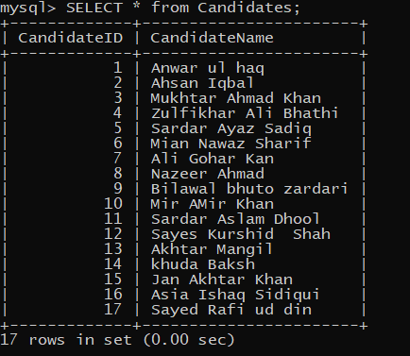

* + 1. **TABLE: WINNINGCANDIDATES**

**Query:**

SELECT * from winningcandidates;

**Output:**

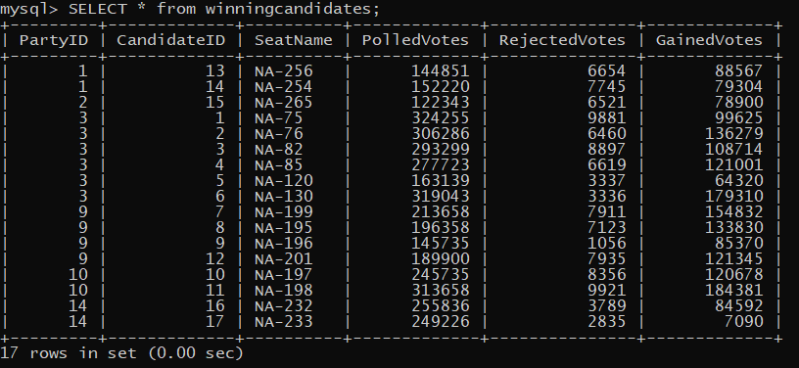

* + 1. **TABLE: PARTYSYMBOLS**

**Query:**

SELECT * from PartySymbols;

**Output:**

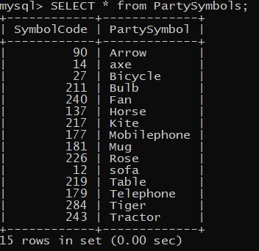

* + 1. **TABLE: PROVINCEWISEVOTERS**

**Query:**

SELECT * from ProvinceWiseVoters;

**Output:**

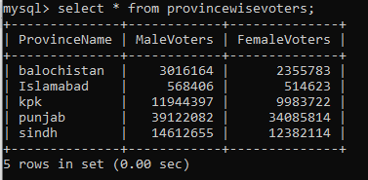

* + 1. **TABLE: PARTYPOSITIONS**

**Query:**

SELECT * from PartyPositions;

**Output:**

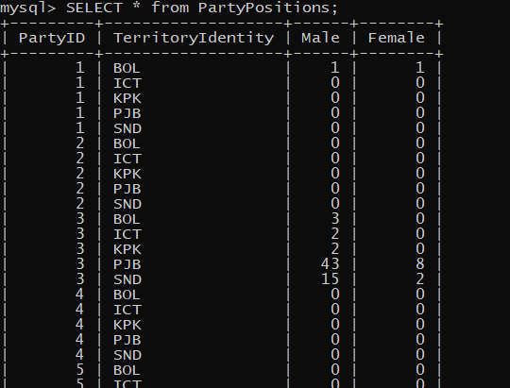

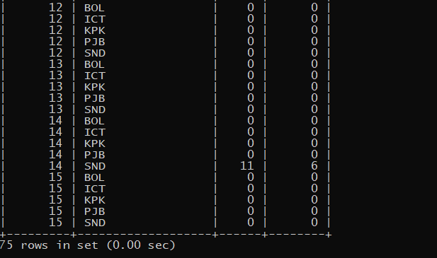

* + 1. **TABLE: SEATSDISTRIBUTION**

**Query:**

SELECT * from SeatsDistribution;

**Output:**

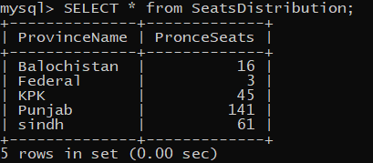

* 1. **QUERIES RESULTS:**

**Query 01:**

Select p.PartyName,p.PartyLeader,cd.CandidateId,c.CandidateName,cd.SeatName,

cd.GainedVotes

from parties p,winningcandidates cd, candidates c

where p.PartyId=cd.PartyId and c.CandidateId = cd.CandidateId;

**Output:**

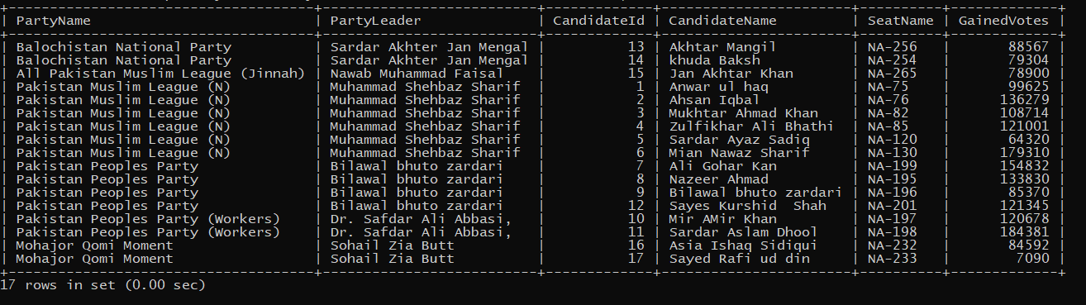

**Query 02:**

select p.PartyName,p.PartyId,sum(pp.male) as TotalMales,sum(pp.female) as TotalFemales

from parties p,partypositions pp

where p.PartyId=pp.PartyId

group by p.PartyName

order by TotalMales DESC;

**Output:**

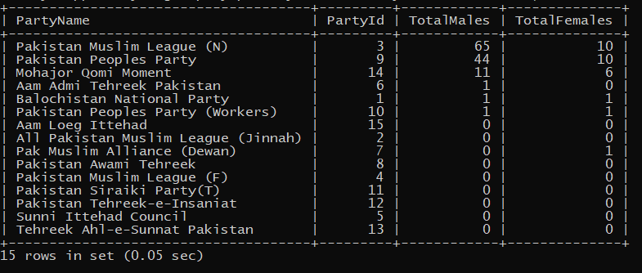

**Query 03:**

select p.PartyName,p.PartyId,sum(pp.male) as TotalMales,sum(pp.female) as TotalFemales

from parties p,partypositions pp

where p.PartyId=pp.PartyId

group by p.PartyName

having p.partyId =3;

**Output:**

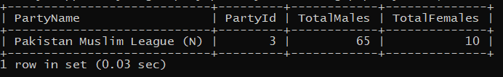

**Query 04:**

SELECT

p.PartyName,

(

SELECT

SUM(wc.GainedVotes)

FROM

winningcandidates wc

WHERE

wc.PartyId = p.PartyId

) AS total_gained_votes

FROM

parties p;

**Output:**

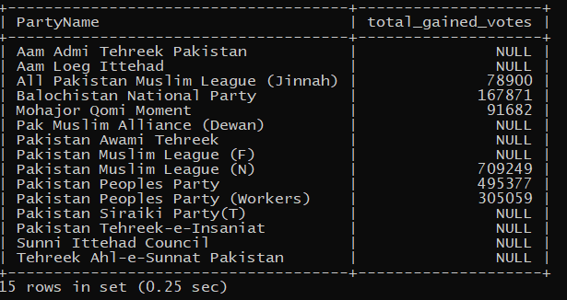

**Query 05:**

select p.PartyId,p.PartyName,p.Isparticipating,cd.SeatName,cd.PolledVotes,cd.RejectedVotes,

cd.GainedVotes

from parties p l

eft join winningcandidates cd

on p.PartyId = cd.PartyId;

**Output:**

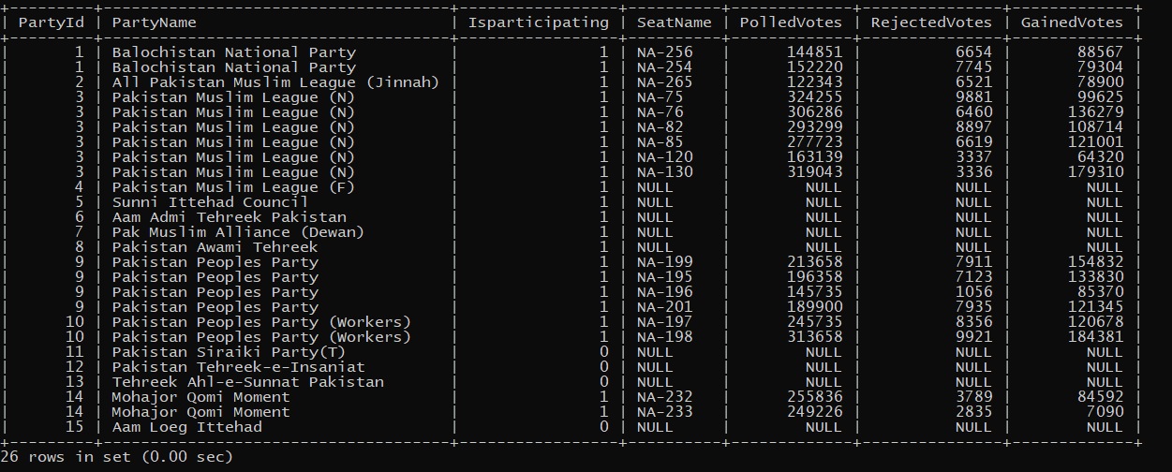

**Query 06:**

select p.PartyId, p.PartyName, ps.PartySymbol

from partysymbols ps, parties p

where p.SymbolCode = ps.SymbolCode;

**Output:**

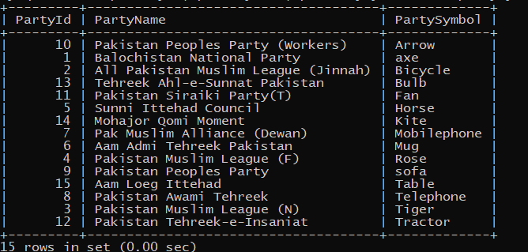

**Query 07:**

SELECT c.CandidateName,cd.GainedVotes

FROM candidates c,winningcandidates cd

WHERE cd.GainedVotes > (SELECT avg(cd.GainedVotes) FROM winningcandidates cd) and c.CandidateId = cd.CandidateId;

**Output:**

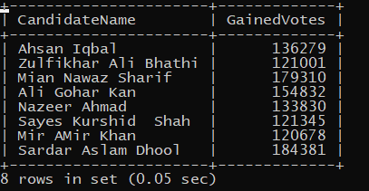

**Query 08:**

select p.PartyName ,sum(male)+sum(female) as TotalSeats

from partypositions pp,parties p

where p.PartyId = pp.PartyId

group by PartyName;

**Output:**

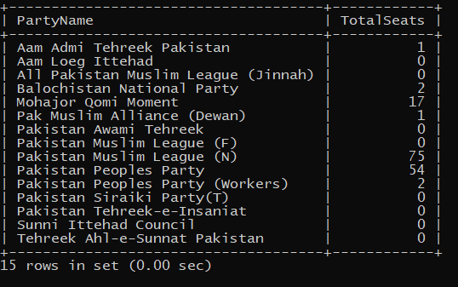

**Query 09:**

SELECT p.partyName, COUNT(cd.CandidateId) AS winners_count

FROM parties p JOIN winningcandidates cd ON p.PartyId = cd.PartyId

WHERE cd.GainedVotes > 70000

GROUP BY p.partyName

HAVING COUNT(cd.CandidateId) > 2

ORDER BY winners_count DESC;

**Output:**

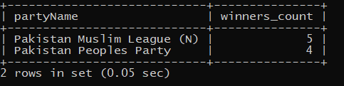

**Query 10:**

SELECT PartyId, PartyName,

(

SELECT COUNT(*)

FROM winningcandidates

WHERE winningcandidates.PartyId = parties.PartyId

) AS candidate_count FROM parties;

**Output:**

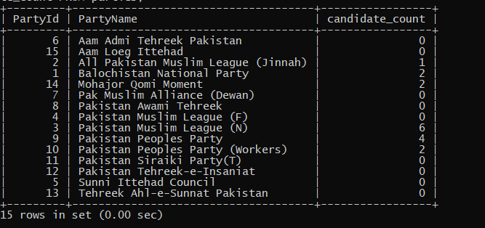

# REFERENCES

*Election Commission of Paksitan*. (n.d.). Retrieved from https://www.ecp.gov.pk/